 Lê Thanh Phương Nam

ITITWE19025

**Report Lab 3 TMC**

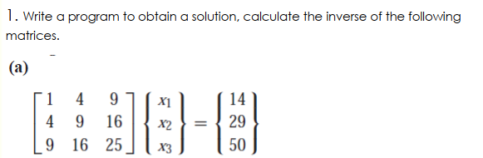

CALCULATE BY HAND

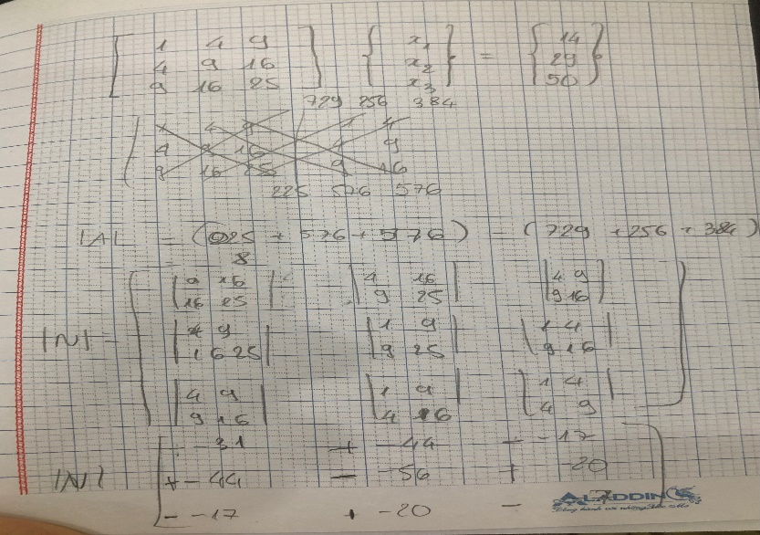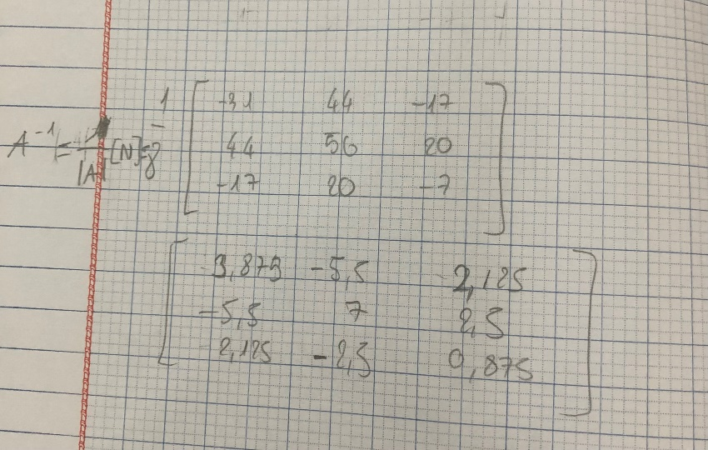

a) Using numpy

Define matrix A using Numpy arrays

Define matrix B

linalg.solve is the function of NumPy to solve a system of linear scalar equations

Code:

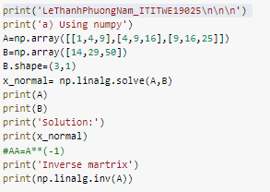

Result:

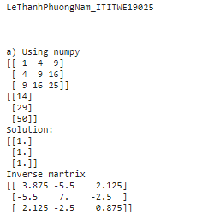

b) Using LU decompision

Solve given LU and B, cal lu_factor to solve for LU

- LU decomposition

+ Finding L and U is finishing

+Solve Linear Equations with LU

- Find Inverse Matrix

+ [A][X]=[L][U][X]=[B]

+ To solve:

Decompose [X] and [B] into multiple vector

Solve for each vector

Code:

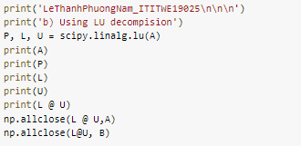

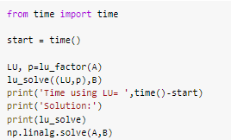

Result:

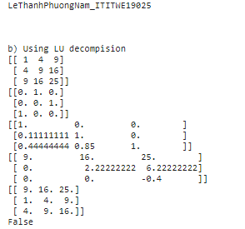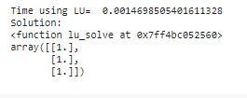

c) Using SVD method

Code:

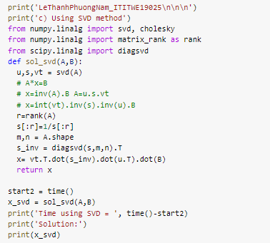

Result:

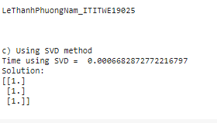

d) Using Gauss Elimination

Code:

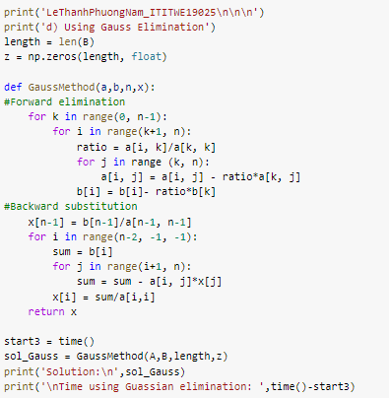

Result:

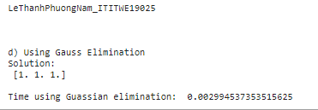

e) Using Using Cholesky

Code:

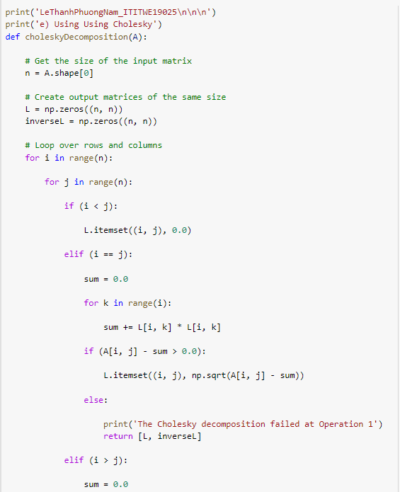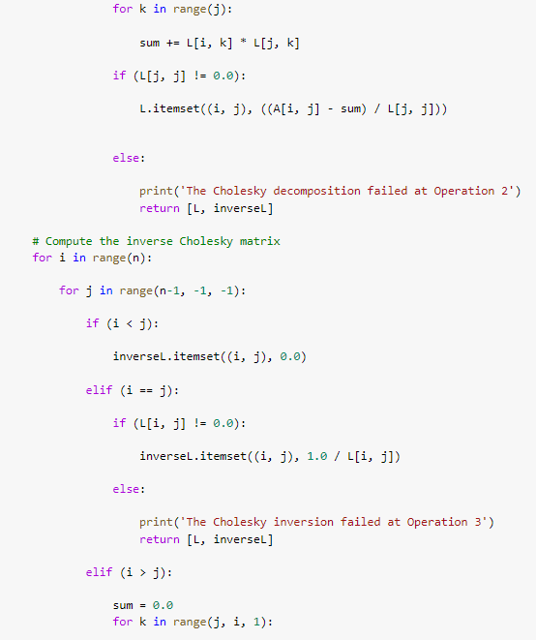

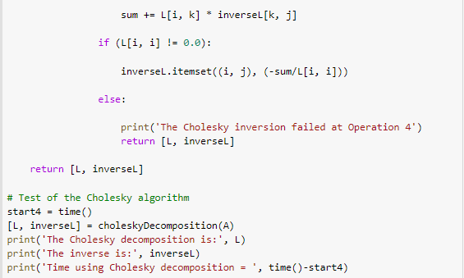

Result:

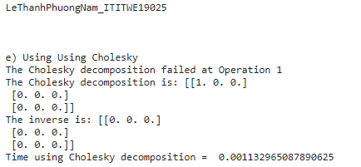

Using Cholesky failed because A isn't a positive definite matrix)

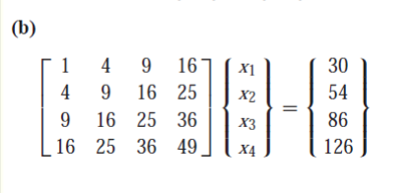

a) Using numpy

Define matrix A using Numpy arrays

Define matrix B

linalg.solve is the function of NumPy to solve a system of linear scalar equations

Code:

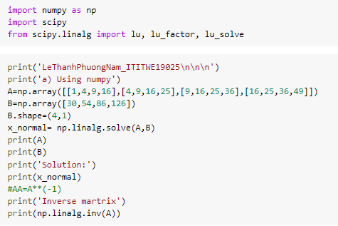

Result:

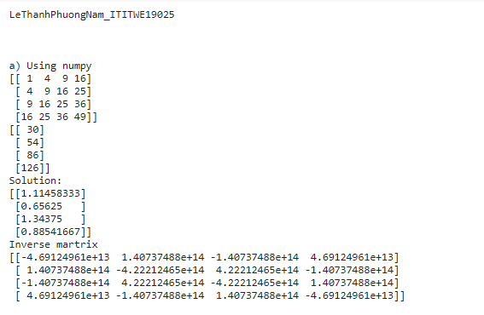

b) Using LU decompision

Solve given LU and B, cal lu_factor to solve for LU

- LU decomposition

+ Finding L and U is finishing

+Solve Linear Equations with LU

- Find Inverse Matrix

+ [A][X]=[L][U][X]=[B]

+ To solve:

Decompose [X] and [B] into multiple vector

Solve for each vector

Code:

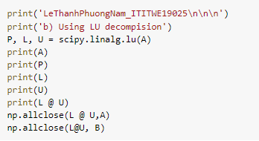

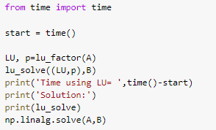

Result:

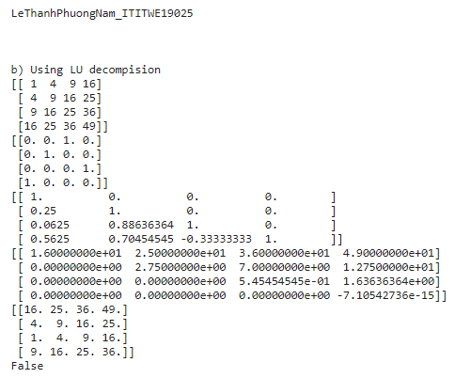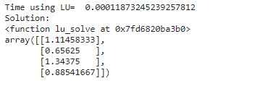

c) Using SVD method

Code:

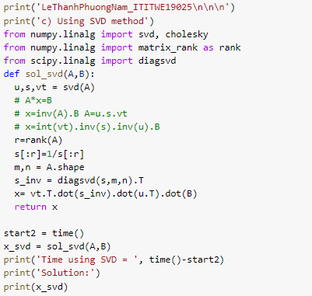

Result:

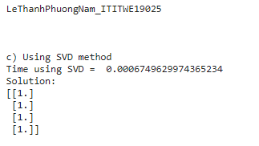

d) Using Gauss Elimination

Code:

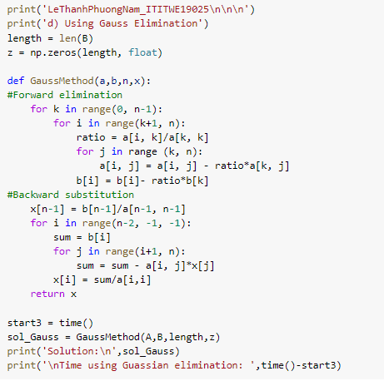

Result:

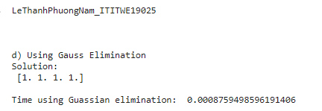

e) Using Using Cholesky

Code:





Result:

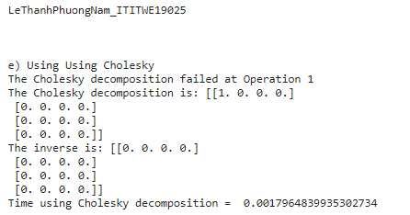

Using Cholesky failed because A isn't a positive definite matrix)